**Azure Traffic Manager – 2 Web Apps**

In this demo we will deploy 2 Web Apps on different location Ex. East Us & West Europe. Create Azure Traffic Manager profile and configure web app as s endpoint.

**Tasks**

**Task 1: Deploy First Web App on East US**

**Task 2: Deploy Second Web App on West Europe**

**Task 3: Configure Traffic Manager**

**Task 4: Test Traffic Manager**

**Task 1: Deploy First Web App on East US**

**Step 1:** Open **Microsoft Azure Portal**

<https://portal.azure.com/>

**Step 2:** Create **Web App**

**+ Create a resource -> Web -> Web App**

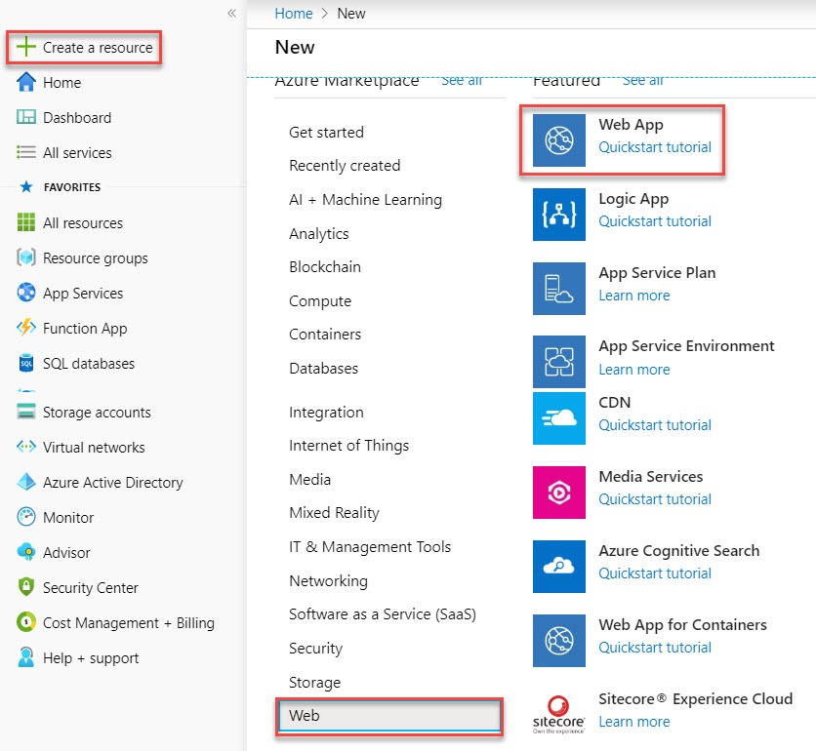

**Step 3:** Create Web App

Resource Group: **Create New Resource Group** Ex. **TrafficManagerWebRG**

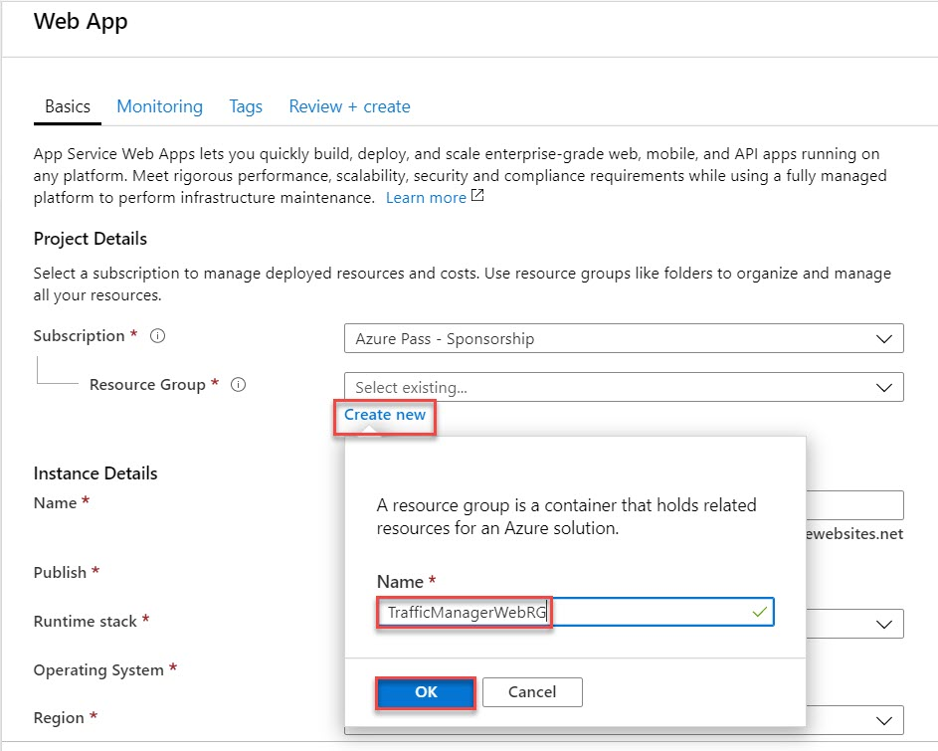

Name: **web-tm-regionname** Ex. **web-tm-eastus**

Publish: **Code**

Runtime stack: **ASP.NET V4.7**

Operating System: **Windows**

Region: **Choose any region** Ex. **East US**

App Service Plan: **Create New**

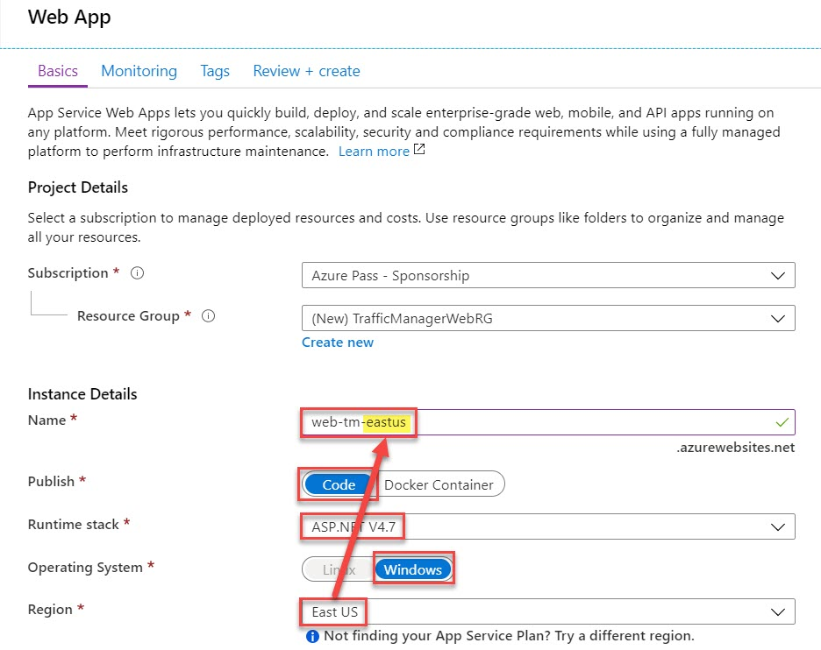

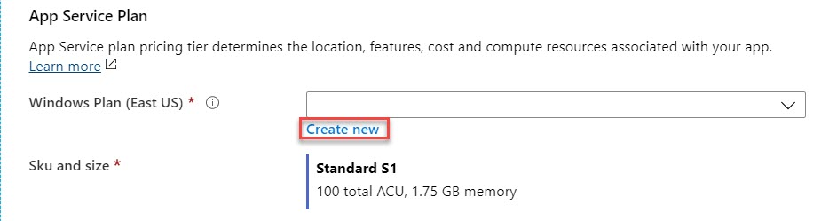

Enter App Service Plan Name: **eastusPlan**

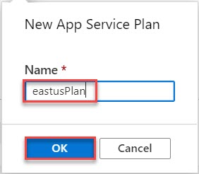

Sku and size: **Standard S1**

Click on **Next: Monitoring >** button

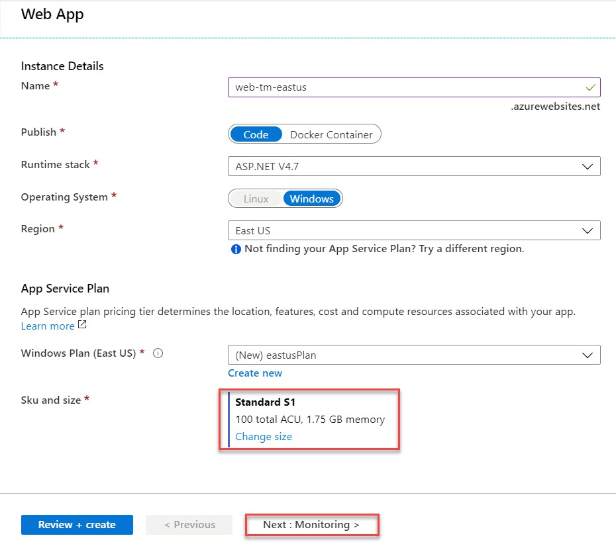

**Step 4:** Application Insights: **Yes**

Click on **Review + create** button

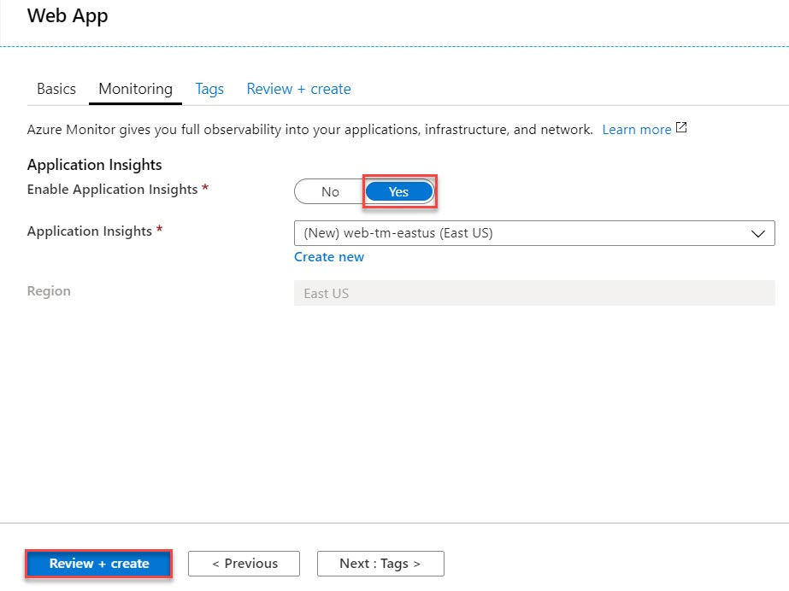

**Step 5:** Click on **Create** button

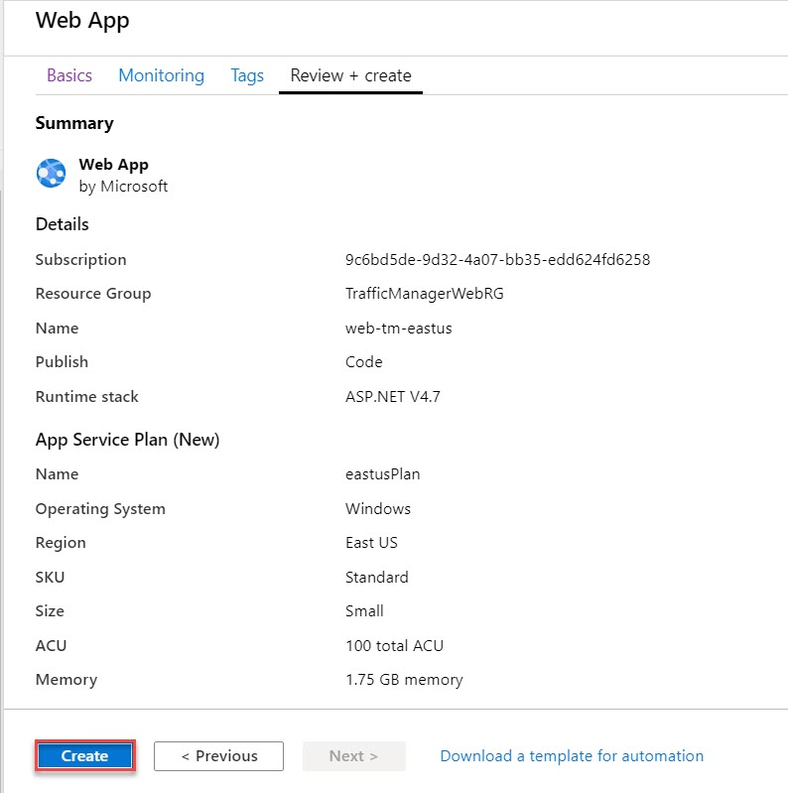

Click on **Go to resource** button

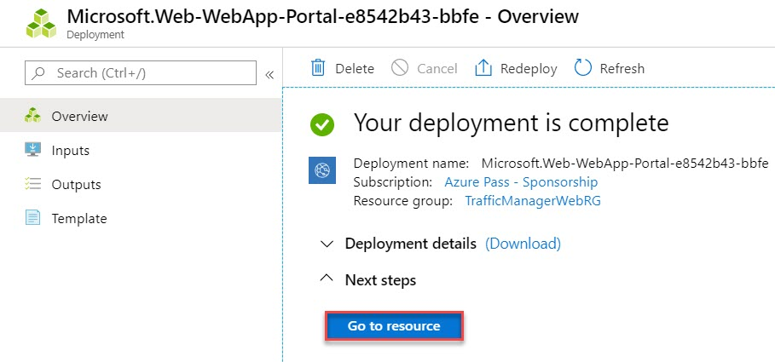

**Step 6:** Click on **Browse** button

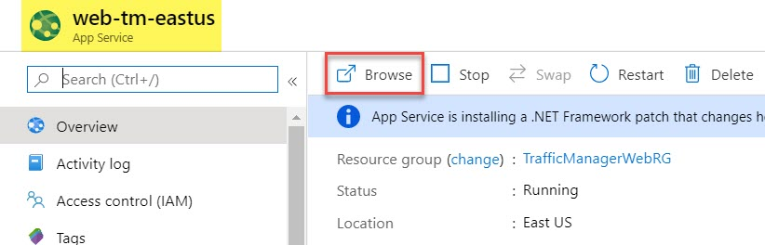

Sample Web Page will open

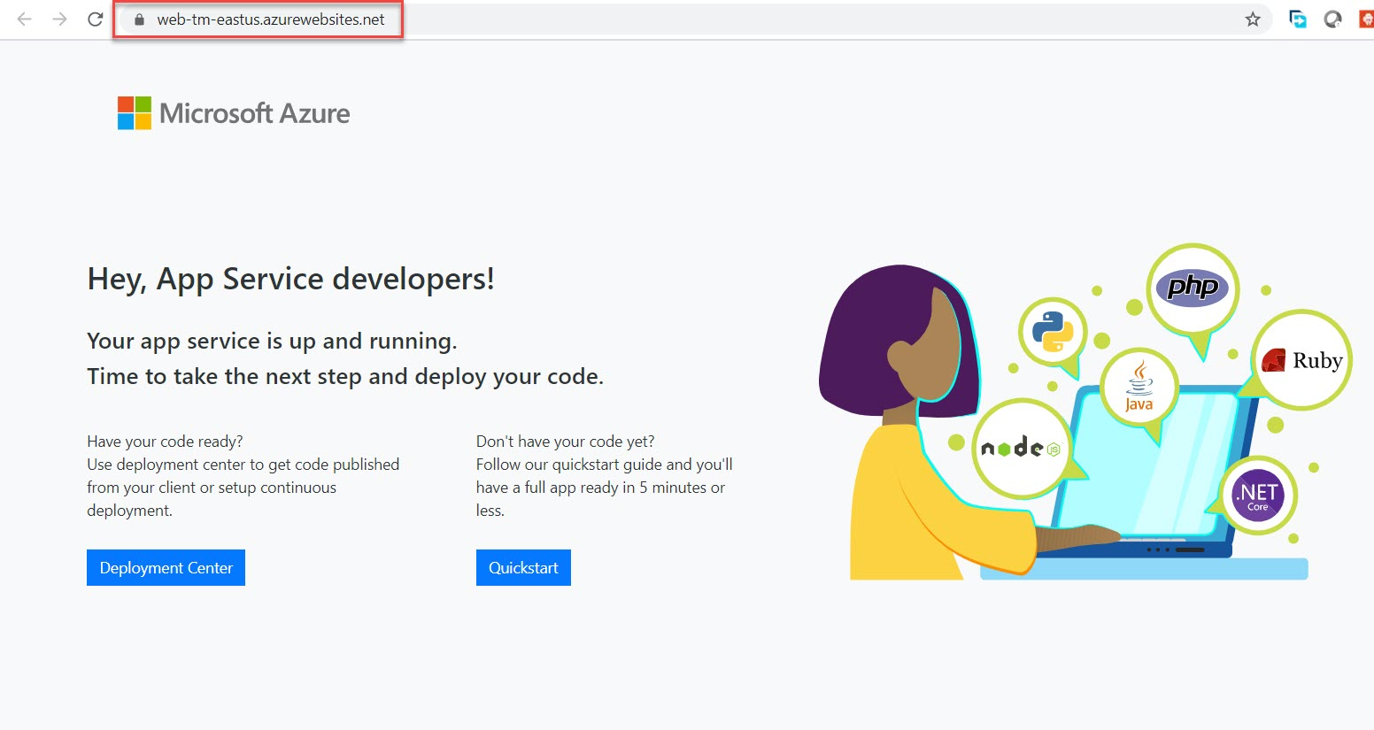

**Step 7:** Back to Azure Web App blade. Search for “**Editor**” and select **App Service Editor (Preview)** option

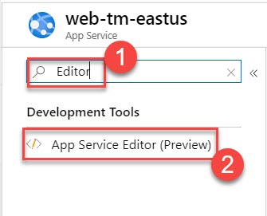

Click on **Go ->** option

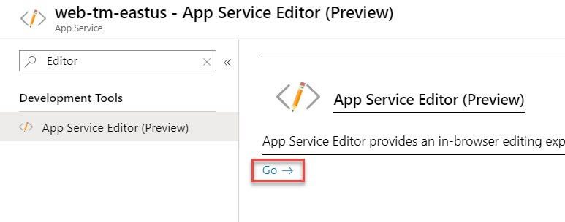

**Step 8:** Select **hostingstart.html** and look for “**Hey, App Service developer!**” line

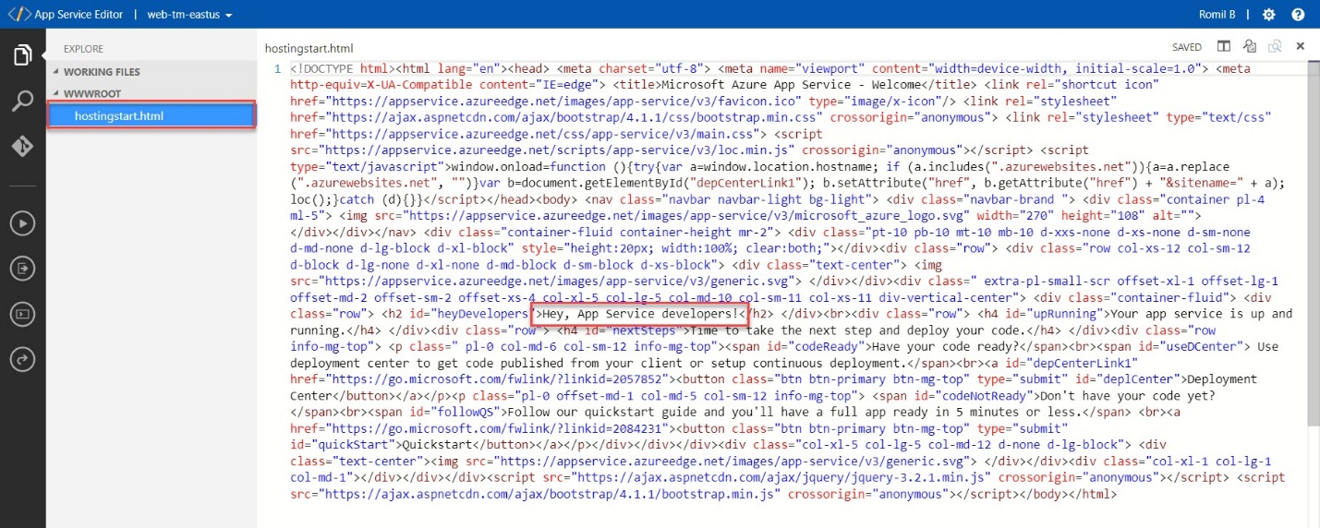

Add region name where you have deployed first web app

Ex. if you have deployed first web app on **East US** region so update as below:

**Hey, App Service developers! – East US**

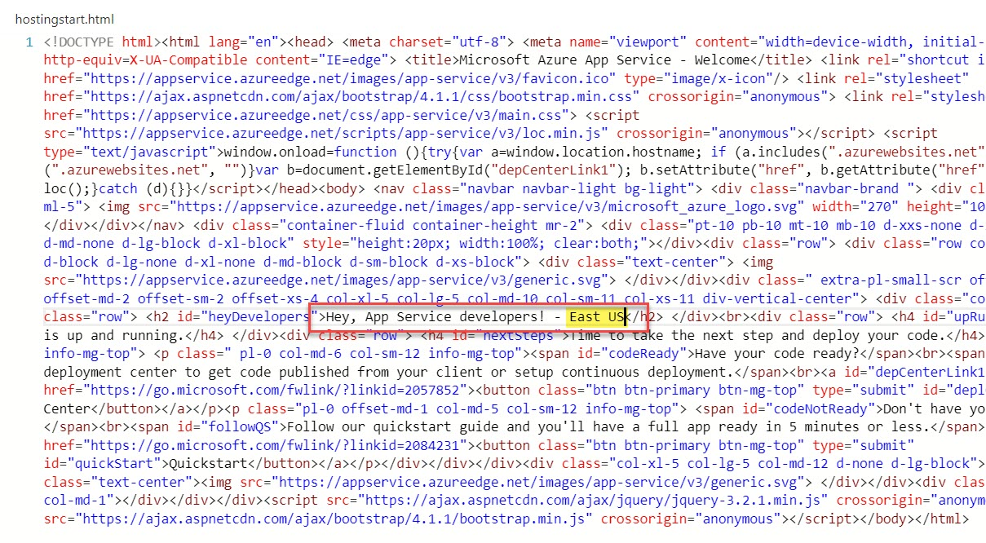

**Step 9:** Back to **Azure Portal blade**.

Remove editor word and select **Overview** option

Click on **Browse** option

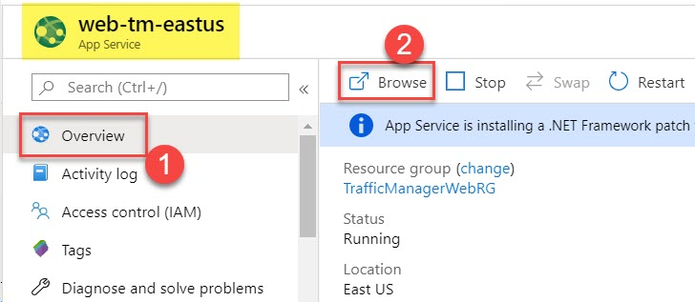

Updated site as below:

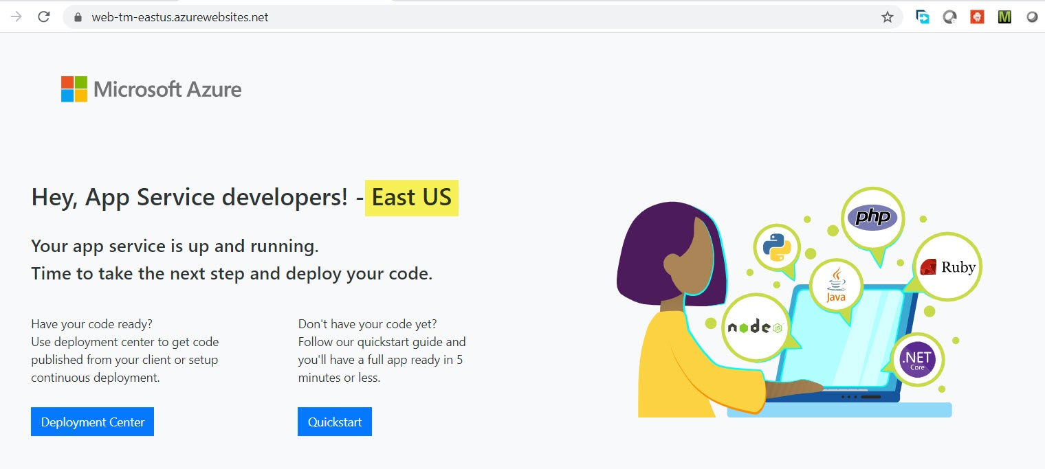

**Task 2: Deploy Second Web App on West Europe**

**Step 10:** Create & Deploy 2nd Web Apps

**+ Create a resource -> Web -> Web App**

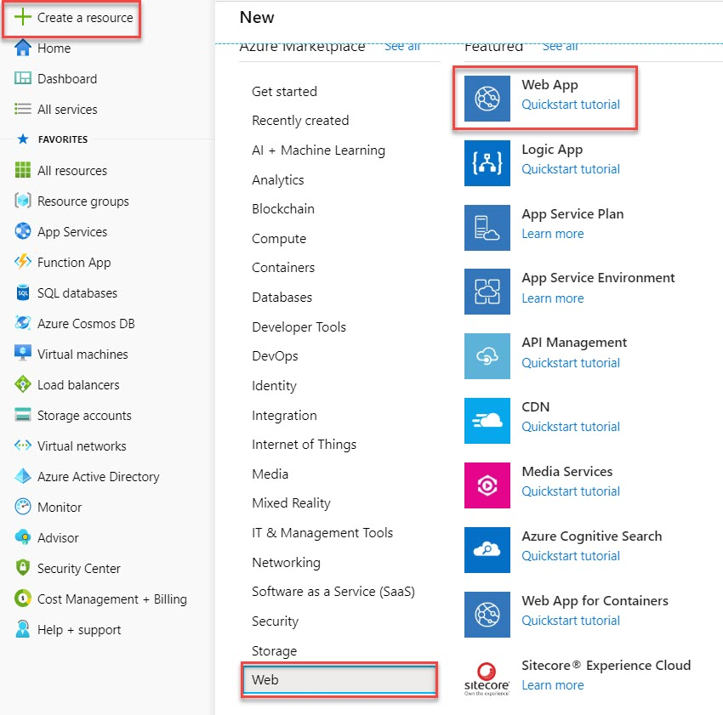

**Step 11:** Resource Group: **Choose existing resource group** Ex. **TrafficManagerWebRG**

Name: **web-tm-regionname** Ex. **web-tm-westeurope**

Publish: **Code**

Runtime stack: **ASP.NET V4.7**

Operating System: **Windows**

Region: **West Europe**

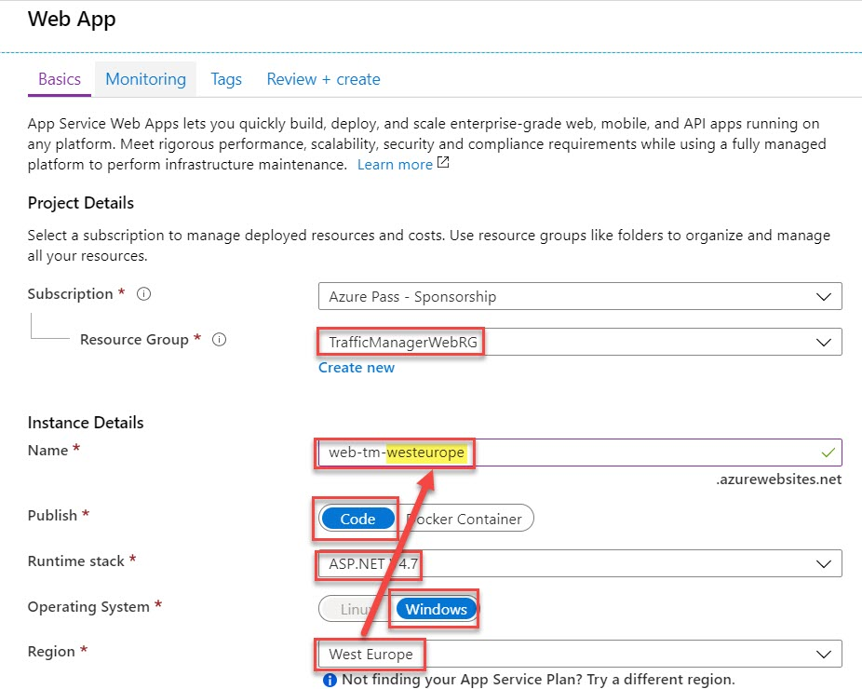

App Service Plan: **Create New App Service Plan** Ex. **westeuropePlan**

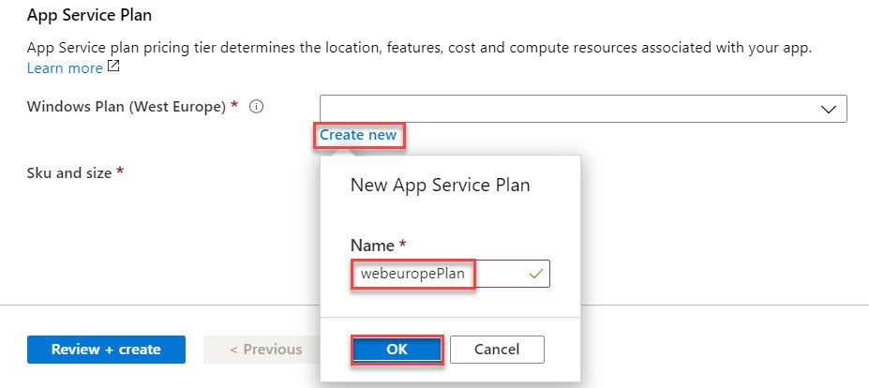

Sku and size: **Standard S1**

Click on **Next: Monitoring >** button

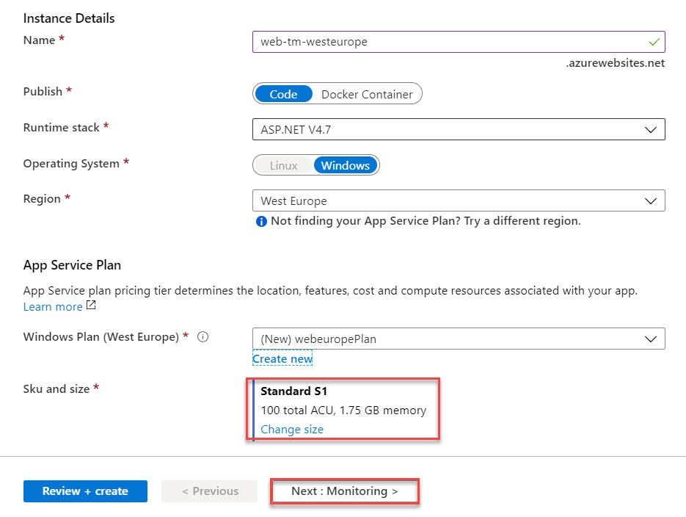

**Step 12:** Application Insights: **Yes**

Click on **Review + create** button

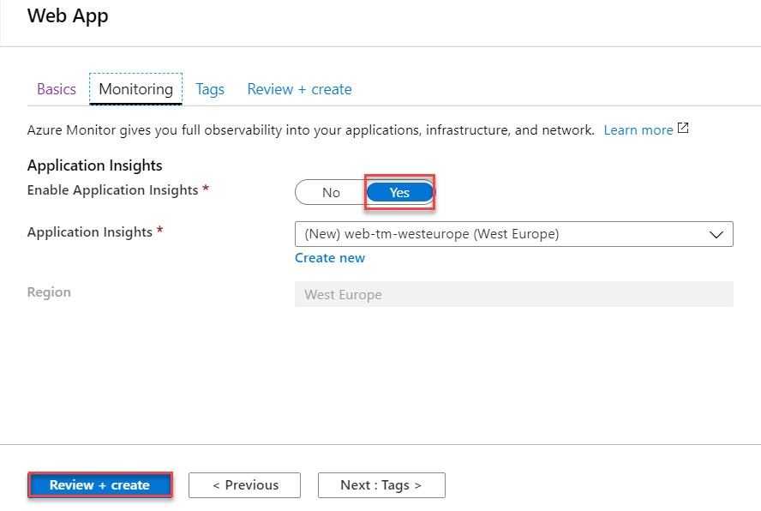

**Step 13:** Click on **Create** button

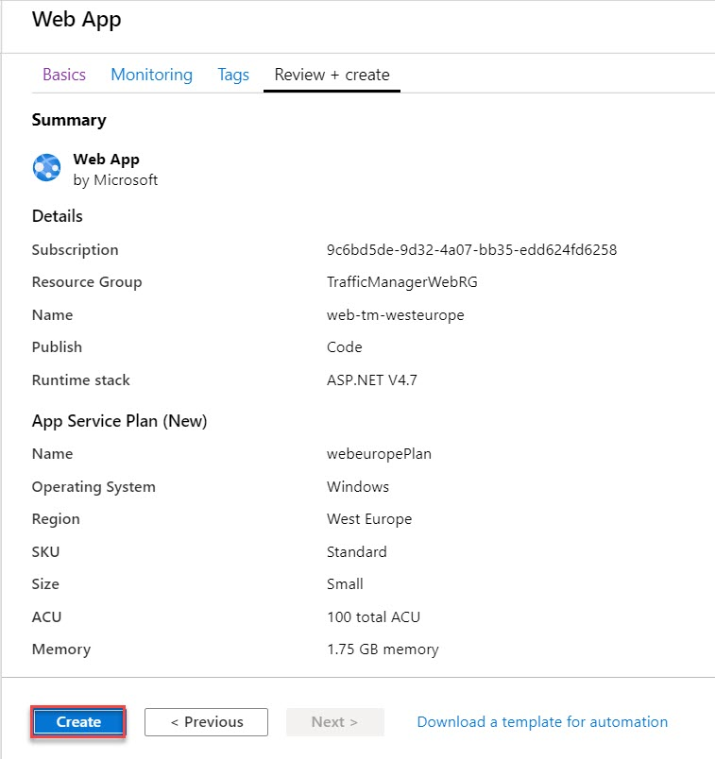

Click on **Go to resource** button

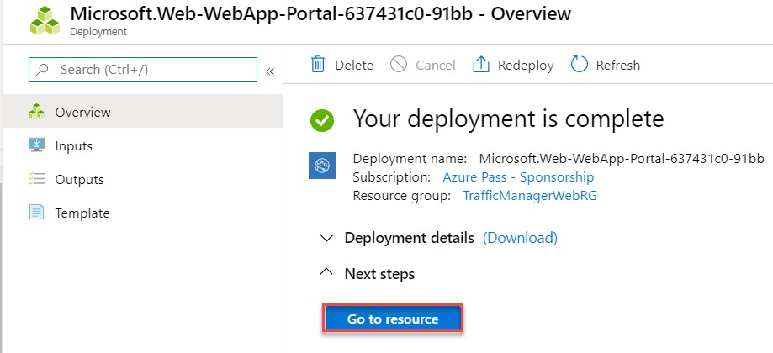

**Step 14:** Click on **Browse** option

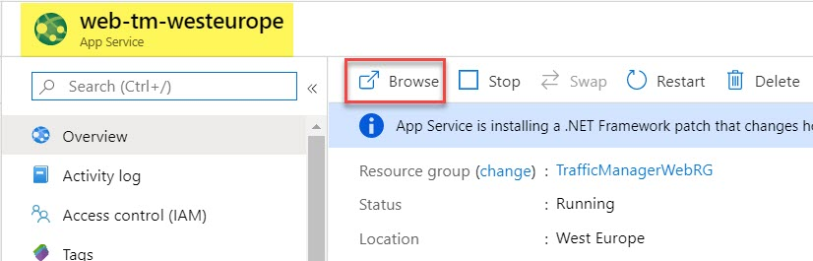

Sample Web Page will open

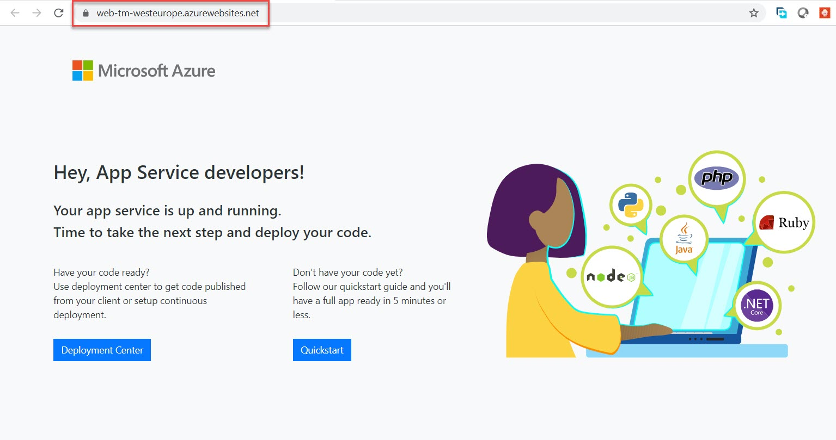

**Step 15:** Back to Azure Web App blade. Search for “**Editor**” and select **App Service Editor (Preview)** option

Click on **Go ->** option

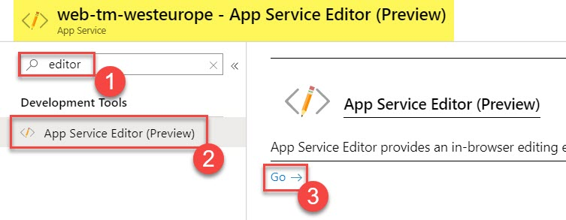

**Step 16:** Select **hostingstart.html** and look for “**Hey, App Service developer!**” line

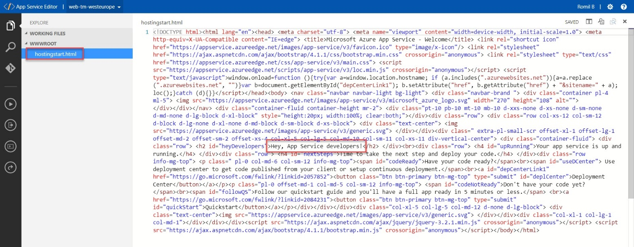

Add region name where you have deployed second web app

Ex. if you have deployed first web app on **West Europe** region so update as below:

**Hey, App Service developers! – West Europe**

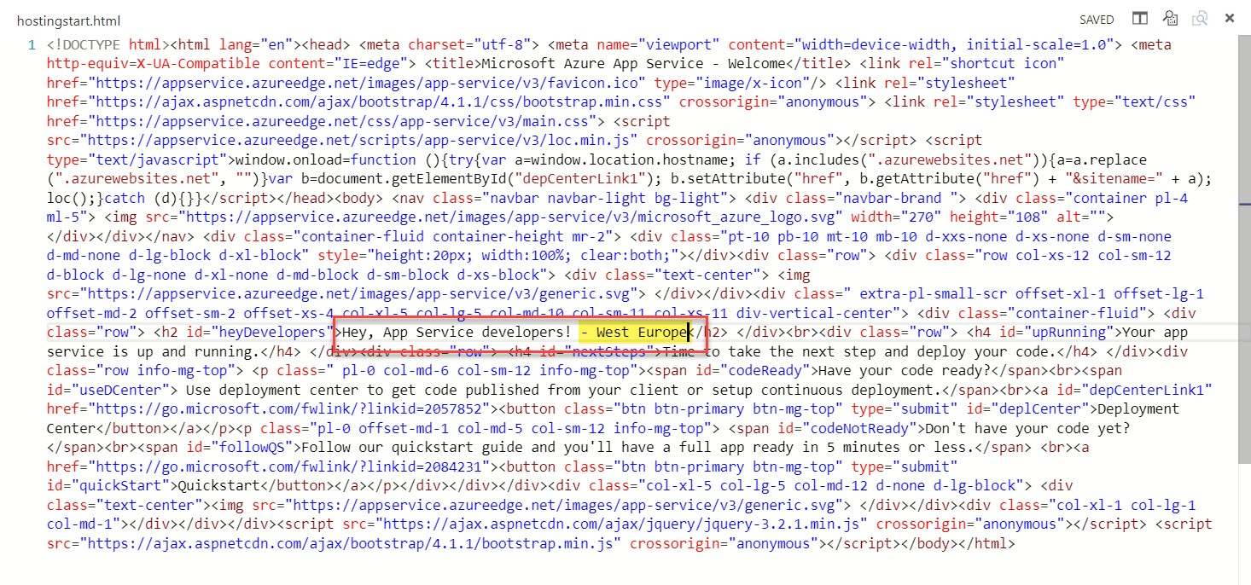

**Step 17:** Back to Azure Portal blade.

Remove editor word and select **Overview** option

Click on **Browse** option

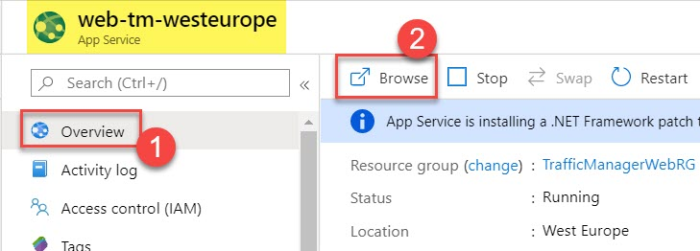

Updated site as below:

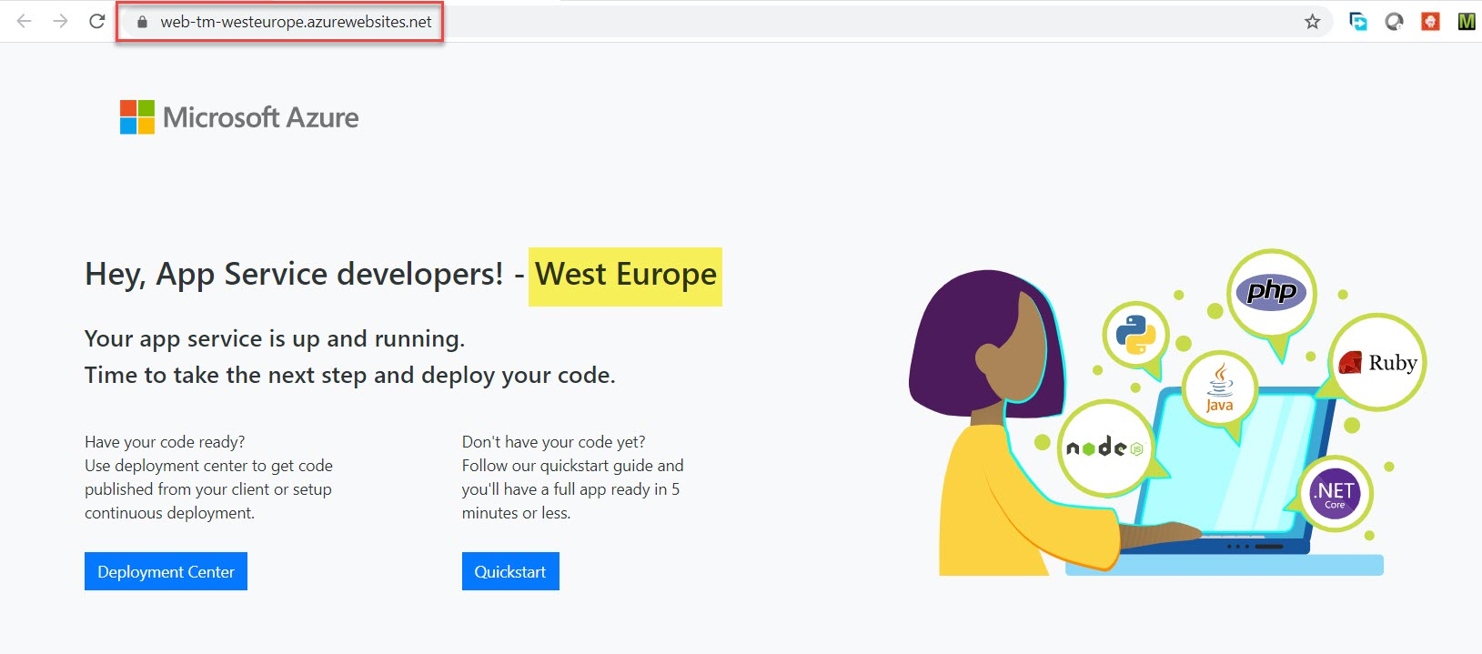

**Task 3: Configure Traffic Manager**

**Step 18: Configure Traffic Manager**

**+ Create a resource ->** search for **traffic manager**

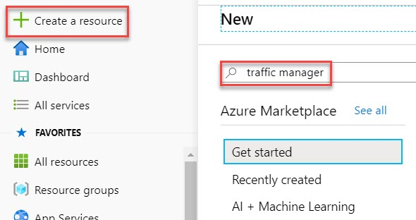

Select **Traffic Manager profile**

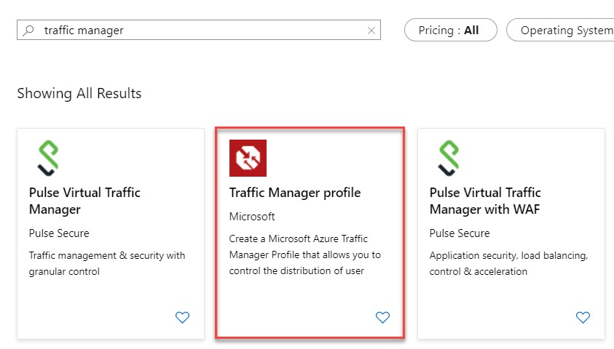

Click on **Create** button

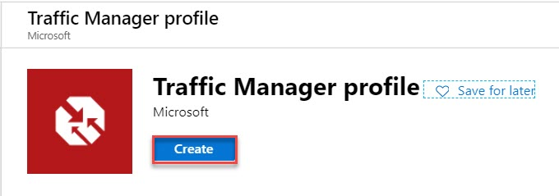

**Step 19:** Create Traffic Manager

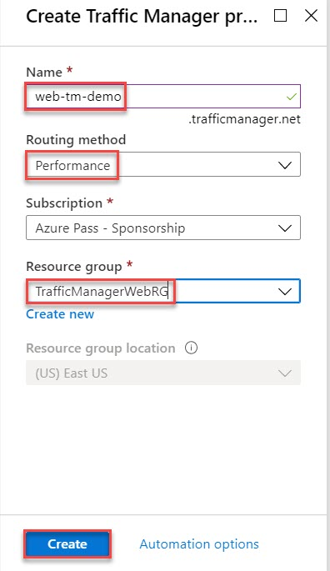

Name: **Enter Traffic Manager Unique name**

Ex. web-tm-demo

Routing method: **Performance**

Subscription: **Choose active Subscription**

Resource Group: **Choose existing resource group**

Ex. **TrafficManagerWebRG**

Select **Notification** and click on **Go to resource** button

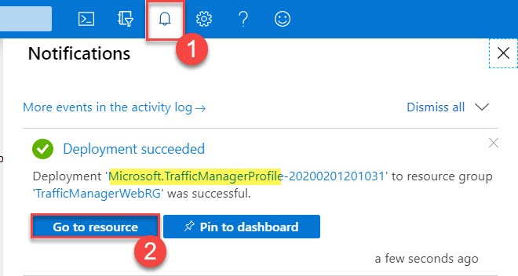

**Step 20:** Now time to configure Endpoints

Select **Endpoints** and click on **+ Add** option

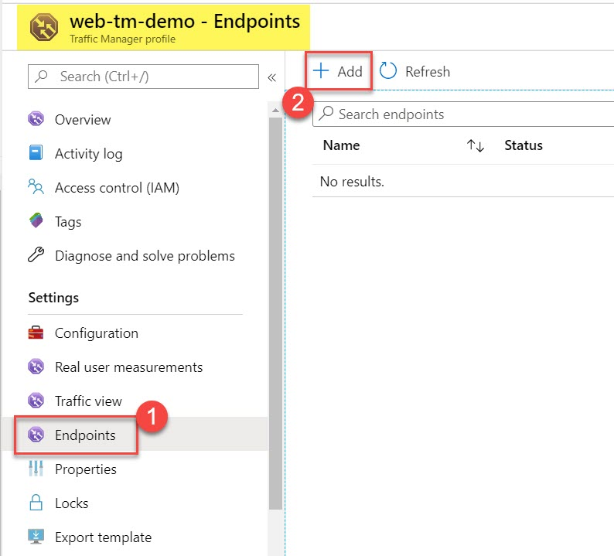

**Step 21:** Add Endpoint

Type: **Azure endpoint**

Name: **web1**

Target resource type: **App Service**

Target resource: **Choose first web app** Ex. **web-tm-eastus**

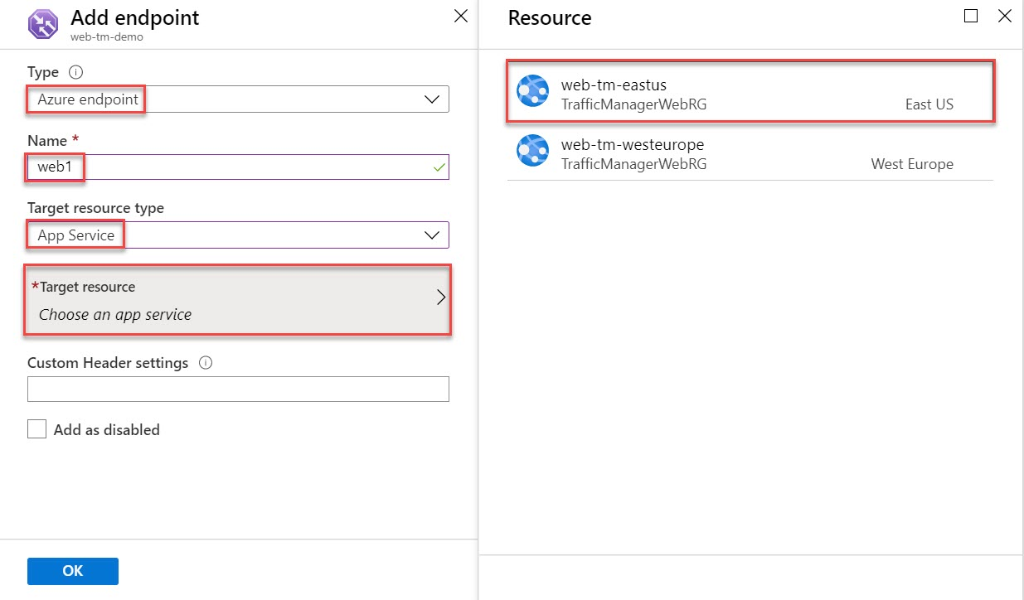

Click on **OK** button

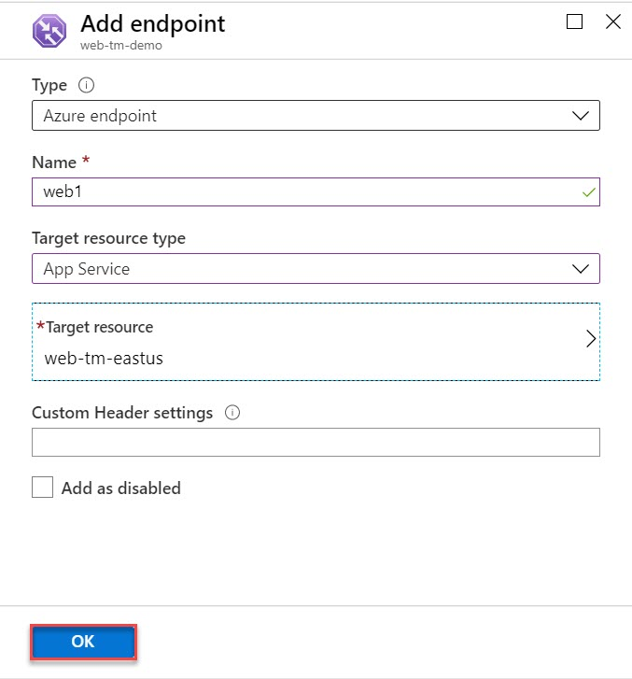

**Step 22:** As recently added so it will take couple of seconds to update status from Checking endpoint to Online.

Click on **Add** option to add another endpoint

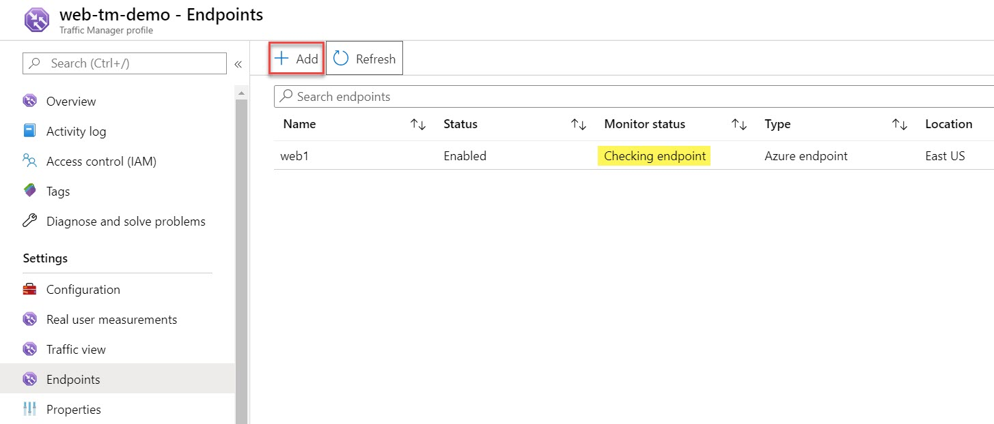

**Step 23:** Add Endpoint

Type: **Azure endpoint**

Name: **web2**

Target resource type: **App Service**

Target resource: **Choose second web app** Ex. **web-tm-westeurope**

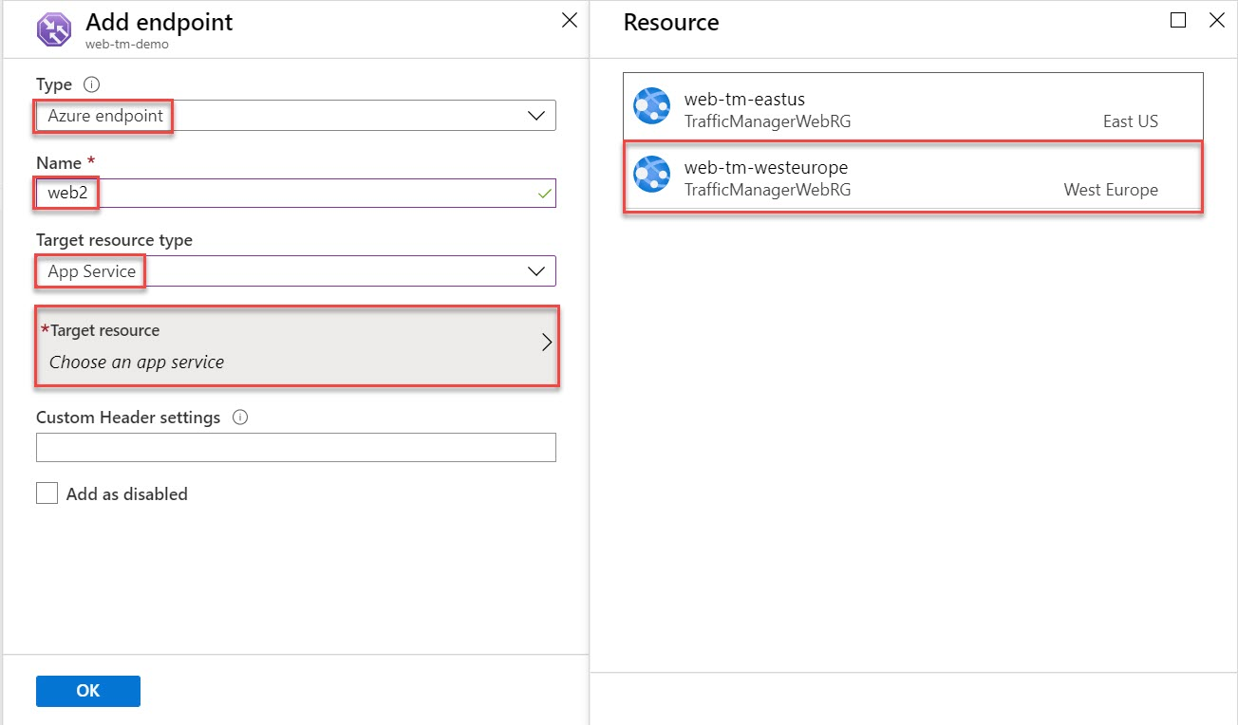

Click on **OK** button

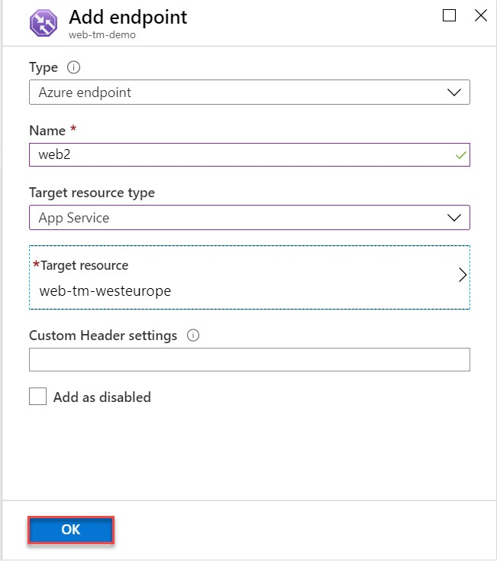

As recently added so it will take couple of seconds to update status from Checking endpoint to Online. To get update on monitor status click on **Refresh** button.

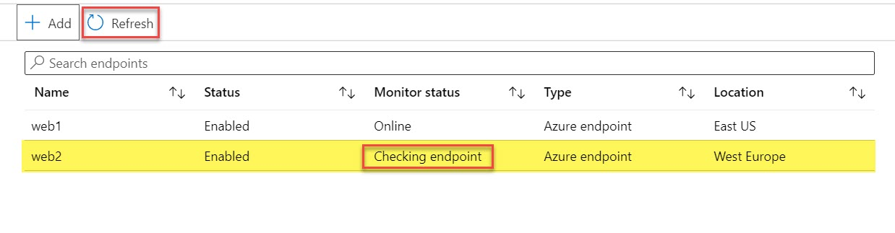

Both endpoint monitor status: **Online**

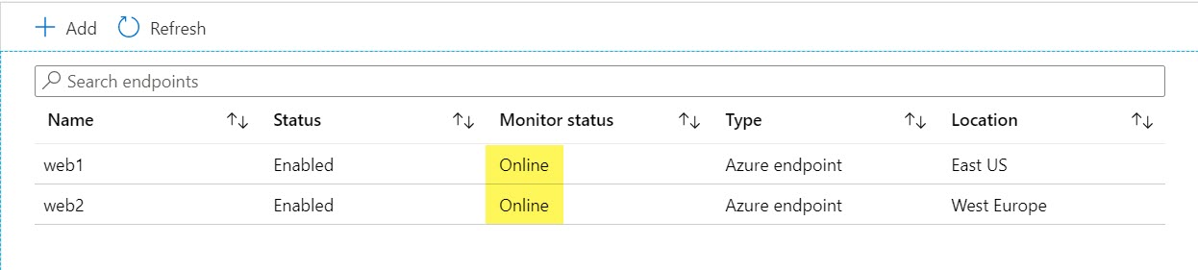

**Step 24:** Click on **Overview** option of traffic manager

**Copy DNS Name**

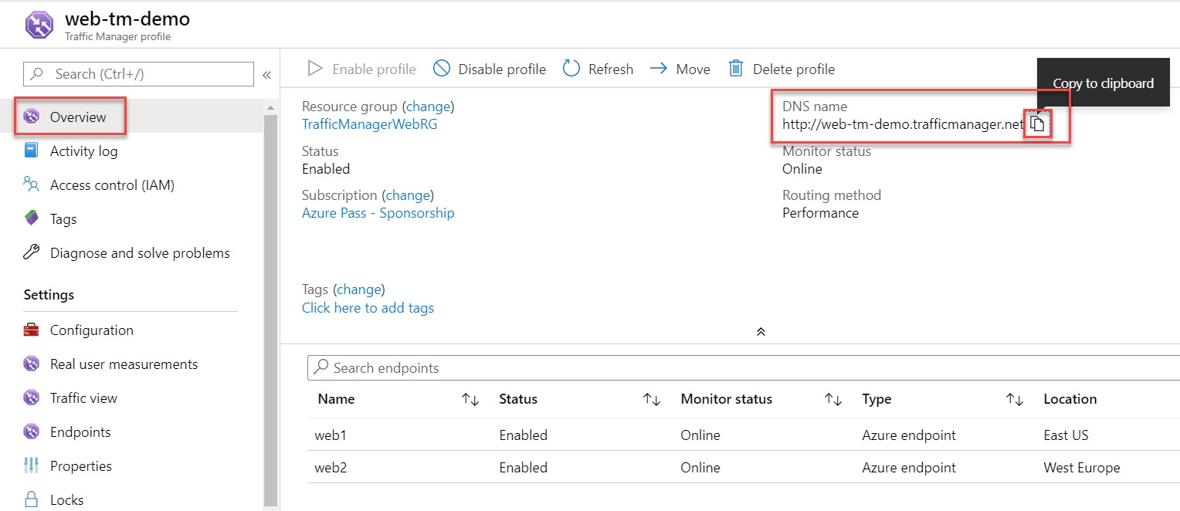

**Step 25:** Open browser and paste traffic manager. Based on routing method performance it will open. Ex. West Europe.

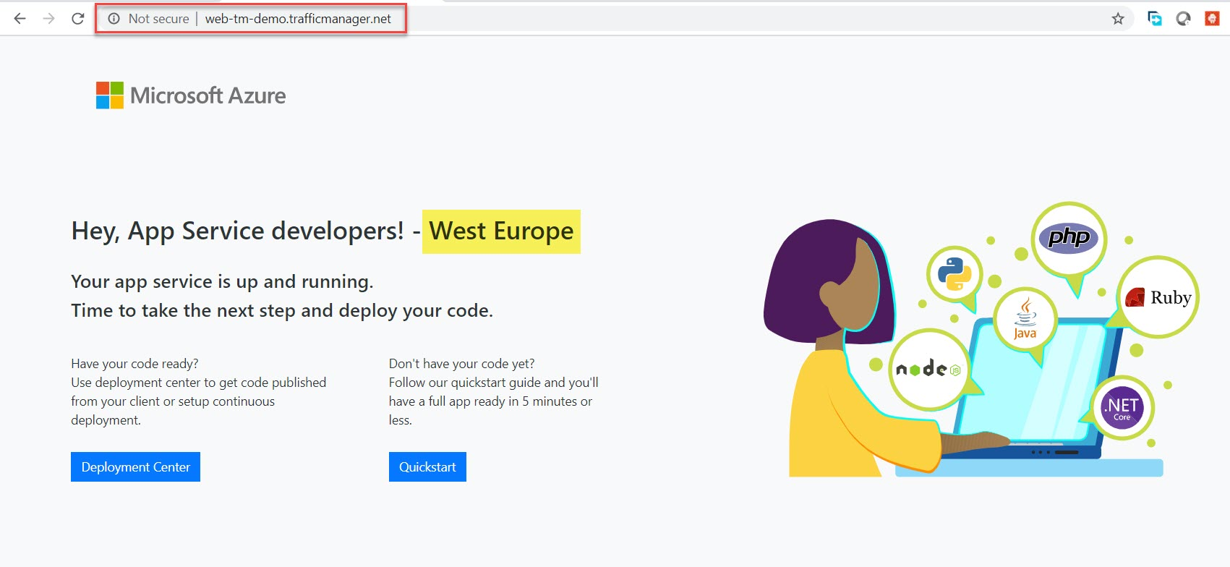

**Task 4: Test Traffic Manager**

**Step 26:** Test Traffic Manager

Open <http://whatsmydns.com/>

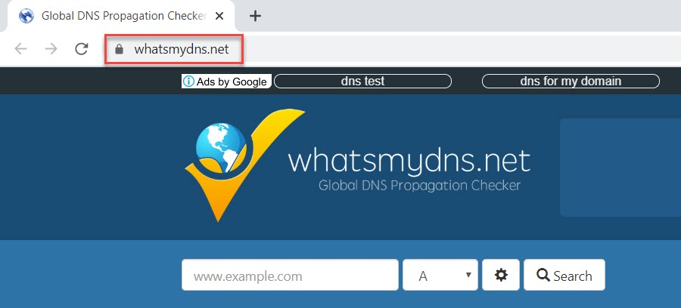

**Step 27:** Enter **Traffic Manager DNS address** and change option to **CNAME**

Click on **Search** button.

Verify location with backend link of web app

